**BRAND DEVELOPMENT GUIDE**

Please supply the following information to assist us develop a comprehensive brief and a clear way forward in the development of your brand.

**Brand Values**

1.     **Company mission statement:** This is a sentence or two that explains your company’s goals. It should also weave in some information about what your organization is and why it exists.

2.    **Product/services positioning statement:** This is like your company mission statement, only more specific to your offerings. Here’s Volvo’s for an example:

*“For upscale American families, Volvo is the family automobile that offers maximum safety.”*

3.    **Benefit of your product/service:** Does it save your customers money? Does it help them increase ROI? Think about how exactly you’re helping your target audience.

4.     **Five words that represent your brand:** Think about your brand’s personality. How would you describe it?

5.     **Three messages your brand needs to communicate:** Why does your brand matter? These messages should be relevant to your target audience.

6.     **Value proposition:** How do you solve your customers’ problems? This should summarize why someone should buy your product or invest in your services.

**Brand Attributes**

The following questions will dive into the essence and identity of your brand.

7.     How does your brand’s image fall between these opposing characteristics?

* *Masculine/Feminine*
* *Simple/Intricate*
* *Grey/Colorful*
* *Conservative/Extravagant*
* *Approachable/Authoritative*
* *Necessity/Luxury*
* *Fun/Serious*
* *Professional/Casual*
* *Modern/Classic*
* *Sporty/Elegant*
* *Extreme/Safe*

8.     What colors represent your brand?

9.     What colors would you not like to see?

10.  What words would you use to describe your brand’s image?

11.  What words would you not want used to describe your brand’s image?

12.  What attributes and/or emotions do you want associated with your brand?

13.  What attributes and/or emotions would you not want associated with your brand?

**Abstract Values**

To answer the following questions, use your imagination to think of your brand in unique situations.

14.  How would you describe your brand to a friend?

15.  How would you describe its style?

16.  What other brands would be its friends?

17.  Where would your brand hang out?

18.  Age? Gender?

19.  What actor/actress would be perfect to play your brand? Why?

20.  What kind of car would your brand be?

21.  What animal would represent your brand?

**Design**

Now we’re getting into the look and feel of your brand. At this point, you can let us develop the direction and design according to what we feel would be the best direction for your brand. However, there are clients who already have an idea of what they want. If you are such a client, the following section will help you communicate your idea efficiently and help narrow down your visual preferences.

22.  Which one of the following categories of logo formats do you believe best represents your brand?

**Logotype**

This format includes your company’s name in stylized typeface and/or your company initials in a simple shape.

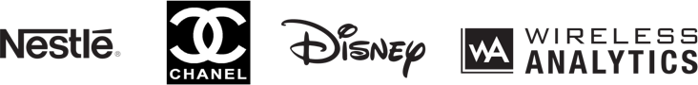

**Pictorial Mark**

This mark includes literal or representative imagery to symbolize your brand.

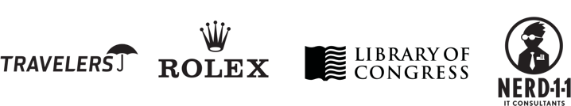

**Abstract Mark**

This format includes abstract shapes and symbols that convey a specific idea or attribute. These types of logos are very unique and identifiable often without the company name.

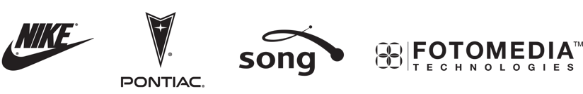

**Emblem or Enclosure**

This features the name or initials of the company, usually as part of a pictorial element or shape.

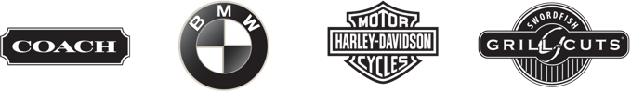

**Web 2.0**

Common elements typically include vibrant colors, a subtle 3D feel, bold type, color transitions, shadows, gloss and reflection.



**Contemporary**

Common elements include fresh colors, stylized imagery and clean type.

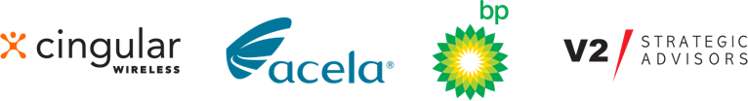

**Classic**

Common elements include timeless colors, literal imagery and traditional type.



**Detailed/Stylized**

Common elements include detail, textures, flowing lines and distinctive type.



**Complex illustration**

These include a hand-drawn feel depicting a scene or character.

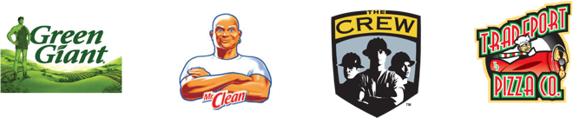

Remember: There’s no need to rush through answering all of these questions! Your responses will ultimately determine your brand’s positioning, so this exercise should take you some time, and can be done together with us during one of our discovery sessions.

We know that a branding project is a lot of work, but rest assured you are already on the right track, and with the right team. If you have any questions or need help discovering your brand, we’re happy to help guide you in the right direction.